Exp No: 7

BUILD AUTOENCODERS WITH KERAS/TENSORFLOW

Aim:

To build autoencoders with Keras/TensorFlow.

Procedure:

1. Download and load the dataset.
2. Perform analysis and preprocessing of the dataset.
3. Build a simple neural network model using Keras/TensorFlow.
4. Compile and fit the model.
5. Perform prediction with the test dataset.
6. Calculate performance metrics.

Program:

import numpy as np

import matplotlib.pyplot as plt

from keras import layers from keras.datasets import mnist from keras.models import Model

def preprocess(array):

"""Normalizes the supplied array and reshapes it.""" array = array.astype("float32") / 255.0 array = np.reshape(array, (len(array), 28, 28, 1)) return array def noise(array):

"""Adds random noise to each image in the supplied array."""

noise_factor = 0.4

noisy_array = array + noise_factor * np.random.normal( loc=0.0, scale=1.0, size=array.shape

)

return np.clip(noisy_array, 0.0, 1.0)

def display(array1, array2):

"""Displays ten random images from each array."""

n = 10

indices = np.random.randint(len(array1), size=n) images1 = array1[indices, :]

images2 = array2[indices, :]

plt.figure(figsize=(20, 4)) for i, (image1, image2) in enumerate(zip(images1, images2)):

ax = plt.subplot(2, n, i + 1)

plt.imshow(image1.reshape(28, 28))

plt.gray() ax.get_xaxis().set_visible(False)

ax.get_yaxis().set_visible(False)

ax = plt.subplot(2, n, i + 1 + n) plt.imshow(image2.reshape(28, 28)) plt.gray() ax.get_xaxis().set_visible(False) ax.get_yaxis().set_visible(False) plt.show()

# Since we only need images from the dataset to encode and decode, we # won't use the labels.

(train_data, _), (test_data, _) = mnist.load_data()

# Normalize and reshape the data train_data = preprocess(train_data) test_data = preprocess(test_data)

# Create a copy of the data with added noise noisy_train_data = noise(train_data) noisy_test_data = noise(test_data)

# Display the train data and a version of it with added noise display(train_data, noisy_train_data)

input = layers.Input(shape=(28, 28, 1))

# Encoder

x = layers.Conv2D(32, (3, 3), activation="relu", padding="same")(input) x = layers.MaxPooling2D((2, 2), padding="same")(x) x = layers.Conv2D(32, (3, 3), activation="relu", padding="same")(x)

x = layers.MaxPooling2D((2, 2), padding="same")(x)

# Decoder

x = layers.Conv2DTranspose(32, (3, 3), strides=2, activation="relu", padding="same")(x) x = layers.Conv2DTranspose(32, (3, 3), strides=2, activation="relu", padding="same")(x) x = layers.Conv2D(1, (3, 3), activation="sigmoid", padding="same")(x)

# Autoencoder

autoencoder = Model(input, x)

autoencoder.compile(optimizer="adam", loss="binary_crossentropy")

autoencoder.summary()

autoencoder.fit( x=train_data, y=train_data, epochs=10, batch_size=128, shuffle=True,

validation_data=(test_data, test_data),

)

predictions = autoencoder.predict(test_data) display(test_data, predictions) autoencoder.fit( x=noisy_train_data, y=train_data, epochs=10, batch_size=128, shuffle=True,

validation_data=(noisy_test_data, test_data),

)

predictions = autoencoder.predict(noisy_test_data) display(noisy_test_data, predictions)

Output:

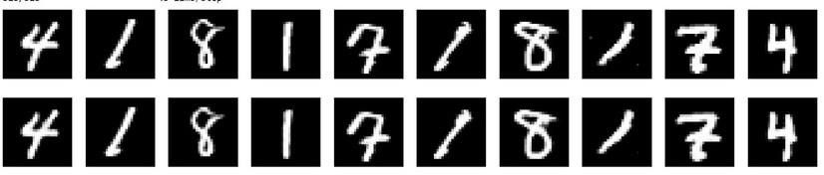

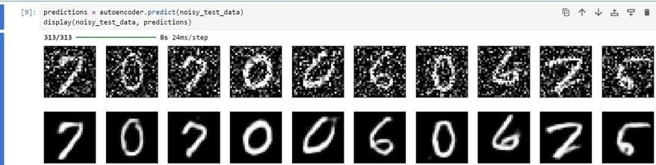

Result:

Autocoder has been successfully built using tensorflow/keras.